# 1.Who collected the data?

Inside Airbnb (IA) is a website founded by Murray Cox. It provides direct access to data reportedly gathered from Airbnb's website. Inside Airbnb has various partners and benefits from the guidance of an advisory board, which helps ensure the sustainability of the project (*About*, no date).

# 2.Why did they collect it?

IA's mission is to offer data-driven insights and advocacy concerning Airbnb's influence on residential neighborhoods (*About*, no date). IA aims to empower communities with data, enabling them to make informed decisions and take control of the roles related to short-term rentals (*About*, no date).

# 3.How was the data collected?

IA utilizes Python scripts to gather public data from Airbnb's website. This data undergoes a meticulous process that includes verification, cleaning, analysis, and aggregation before being published on the IA website. IA makes a commitment to regularly updating this data for each location (Alsudais, 2021).

# 4.How does the method of collection impact the completeness and/or accuracy of its representation of the process it seeks to study, and what wider issues does this raise?

The current data exhibited deficiencies and incompleteness in both key field and record accuracy:

Due to the disclaimer on the IA website, listing location information is anonymized, preventing precise determination of their exact locations. This anonymization may pose accuracy challenges when exploring the geographical distribution of the listings.

If the Airbnb platform deletes the listing information, the IA website may not be updated in time, resulting in information deviation.

In cases where Airbnb removes listing information, there could be a delay in updating the IA website, potentially leading to information discrepancies.

There are many missing values and values with wrong data types in the records of IA data.

The data gathered by IA contains noticeable erroneous comments and lacks specific identification for targeted correction. This issue may escalate as the dataset expands.

# 5.What ethical considerations does the use of this data raise?

For transparency and accountability: all data is downloaded from official websites rather than being conducted by the team, so all data sources are annotated in detail, and specific information about the data is clearly visible on the respective websites.

For data storage and legal compliance, the team used onedrive for inter-team data sharing and storage, preventing unauthorised access and data leakage, which effectively facilitates the process of data handling within the team.

For avoiding bias and discrimination, the team collect data from credible official websites and process the data in a way that is objective, comprehensive and fair, taking into account the specific data of each borough in London.

For data accuracy, some limitations may exist in this data analysis. Since the rental prices were selected using a sampling method to calculate the average price, it cannot reflect the actual price comprehensively and realistically. Since the data came from two different websites, only five consecutive years of data could be collected, and the time-series limitation would affect the accuracy of future price prediction. In addition, the data included contains data from the covid-19 period, and sudden epidemic disasters may also have some effects on prices that exceed the rules of the market, affecting the analyses and judgements.

# 6. With reference to the data (i.e. using numbers, figures, maps, and descriptive statistics), what does an analysis of Hosts and Listing types suggest about the nature of Airbnb lets in London?

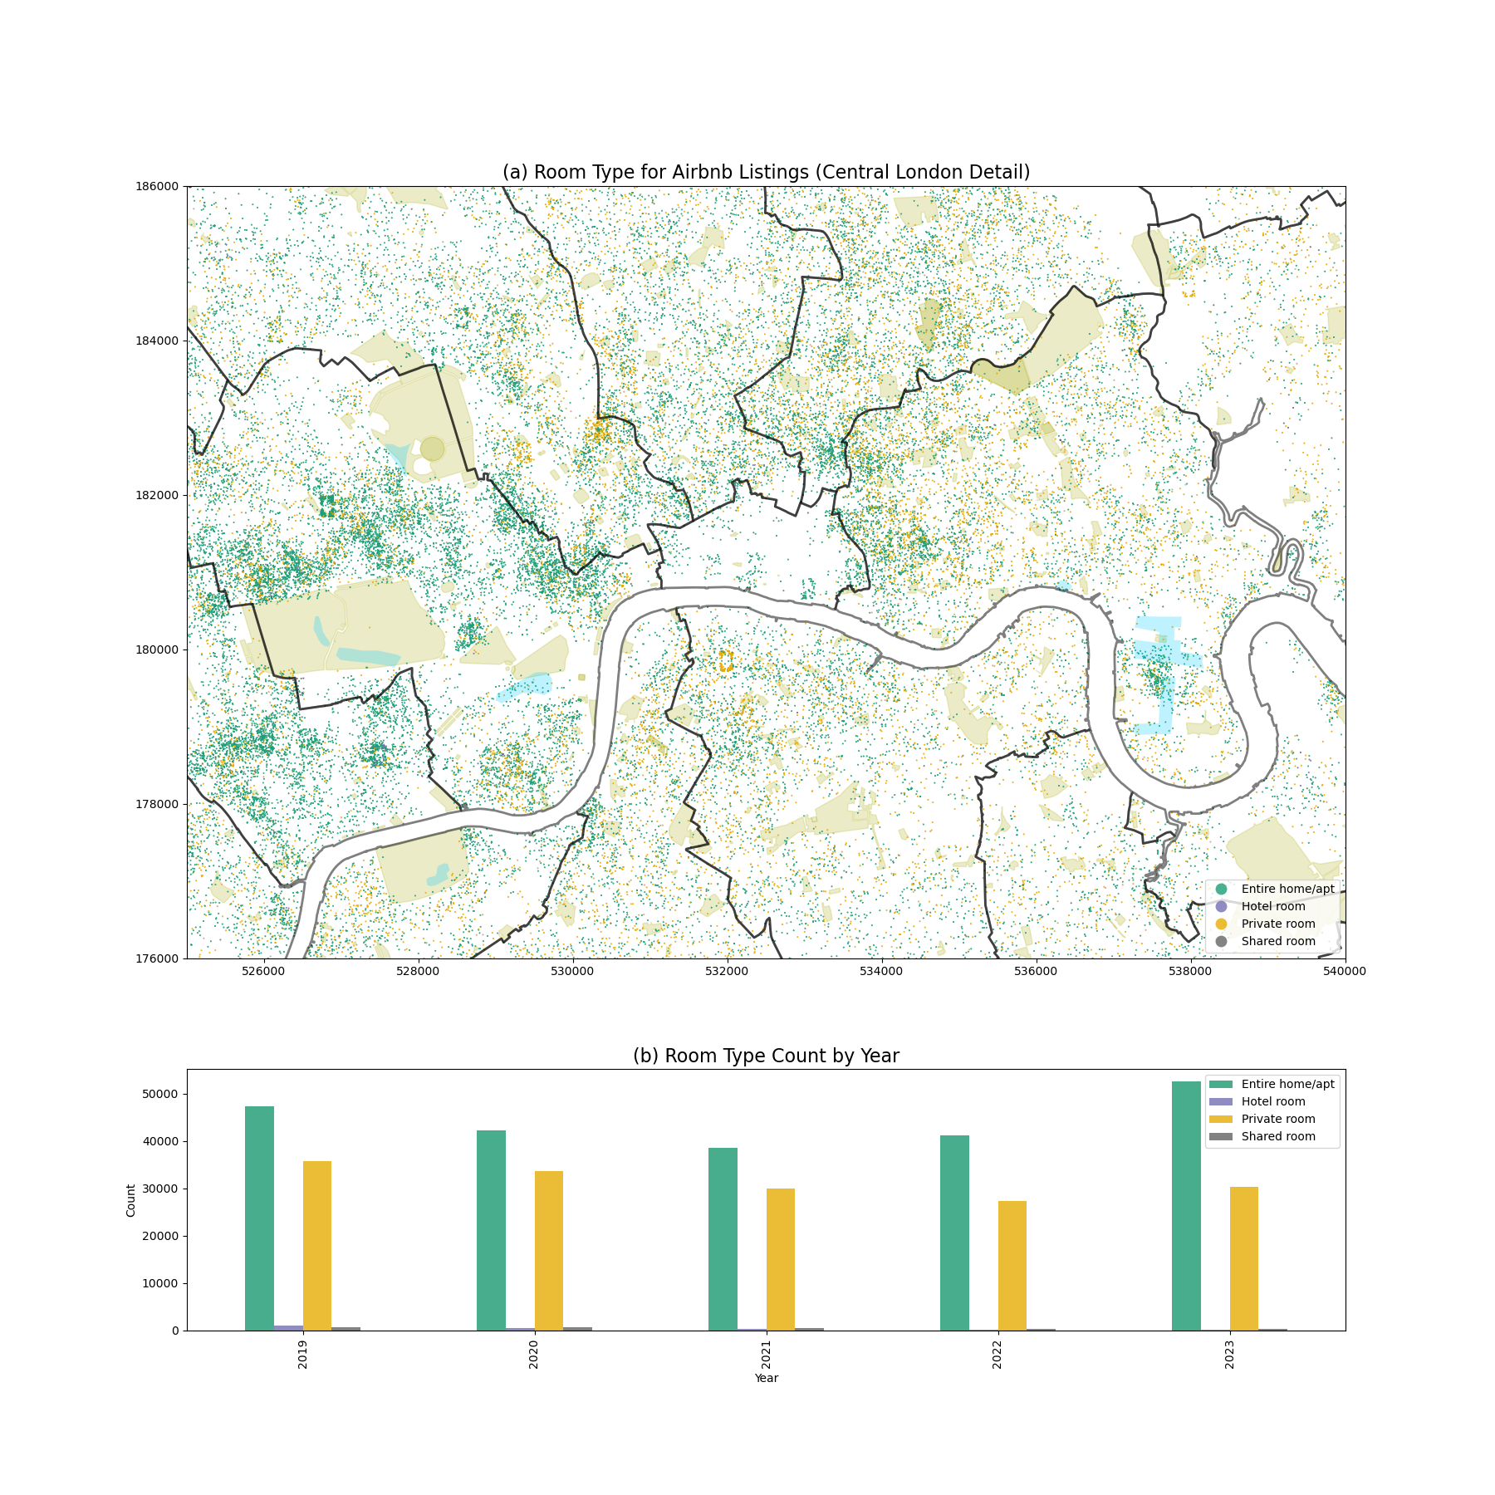

Figure：Room Type for Airbnb Listings and Room Type Count by Year

The chart illustrates the growth of Airbnb listings in London from 2019 to 2023, with a 2023 map showing the predominance of "Entire home/apt" types, clustered north of the Thames. Accommodation numbers dipped initially but rebounded sharply to peak at 80,000 in 2023.

Shabrina (2021) states London landlords can own up to two properties for 180-day rentals each year. Exceeding this is deemed Airbnb abuse. In 2020, compliant and abusing landlords were nearly equal at around 34,000. By 2023, abusers more than doubled to 59,608, dwarfing the 27,966 compliant ones.

We explore why this trend arises. Driven by increasing market demand and financial gains, short-term rentals often yield higher profits than long-term leases, tempting landlords to bypass regulations to maximize market opportunities.

Despite clear regulations, enforcement challenges persist. Landlords may either circumvent the rules or unknowingly breach them due to lack of awareness or understanding. A survey reveals that 86% of landlords claim to proactively seek knowledge about relevant regulations. This suggests that while some are informed, compliance isn't always adhered to, with a few even finding loopholes (Marcus, 2022).

Furthermore, Airbnb implemented a 90-day annual booking cap in 2017 for unmanaged listings (Airbnb, 2020). London's regulatory framework has seen little alteration since (Dorine, 2021). This stagnation might stem from regulatory bodies' resource limitations in enforcement or delays in updating landlords about policy changes (Zahratu, 2021).

# 7. Drawing on your previous answers, and supporting your response with evidence (e.g. figures, maps, and statistical analysis/models), how could this data set be used to inform the regulation of Short-Term Lets (STL) in London?

As international students, the team members have experienced the increasing cost of renting houses in London, making it harder to rent suitable property. Concerning the growing Airbnb market, we wanted to explore the impact of Airbnb on the long-term rental market. After extensive literature reading, the team members found that the rent of long-term rentals in the UK increases with the number of Airbnb listings [1]. It's comprehensible that Airbnb as a short-term rental would impact the same short-term rental industry as the hotel industry, but why would it also affect long-term rentals with a different audience? A phenomenon in Berlin answered the team members' questions. The housing stock in the city will not change drastically in the short timeframe. Still, many platforms and landlords are transforming redundant housing that were initially put on the long-term rental market into short-term rentals by placing them on Airbnb for a higher profit. This behavior has led to an increase in the number of Airbnb listings and a decrease in the number of long-term rentals, which led to a reduction in the supply of long-term rentals and an increase in long-term rentals [2]. Airbnb impacts the long-term rental market in different cities worldwide, especially in some tourist cities. [3] In this context, we want to explore whether Airbnb similarly impacts long-term rentals in the London area qualitatively and quantitatively. Accordingly, we set out to answer the following 4 questions:

1. The effect of London.Airbnb's listing density on long-term rental rents.

2. The effect of London Airbnb's price on long-term rental rents.

3. The effect of the increase in the price of Airbnb in different regions on the rise in the rent of long-term rental properties?

4. The effect of the rise of Airbnb density in different regions on the rise of long-stay rents.

The findings in this report are based on a rigorous analysis of the period 2020-2023, focusing on London boroughs. Except the IA's data, we downloaded average monthly rents for long-term rentals in each borough of London from the office for national statistics website. We processed more than 400,000 pieces of Airbnb data and nearly 10,000 pieces of sampled data of long-term rentals in each London borough and cleaned, screened, filtered, grouped, type-converted, consolidated, and computed all the data using the tools pandas and numpy. Rents were calculated using the following formulae:

**Visualization of key components:**

The visualization provides an intuitive view of the distribution patterns for Airbnb listings and long-term rental prices.

Figure shows that the kernel density of Airbnb listings increases as one approaches the center of London. The detailed area density graph b also shows that the distribution of Airbnb generally follows a pattern of increased density in areas closer to the center of London, with the borough of Kensington and Chelsea having the highest Airbnb density, followed by the borough of Westminster. From Figure c, the Airbnb price also roughly correlates with the density distribution, with the highest prices found in the borough of Kensington and Chelsea, followed by the borough of Westminster. However, Airbnb prices are not strictly and entirely determined by density. For instance, the third highest-priced borough is Barking and Dagenham, which may be associated with other factors such as national urban regeneration policies [4]. Surprisingly, a similar trend was observed in long-term rentals and Airbnb density distribution, as seen in figure d. The highest-priced boroughs are Kensington and Chelsea, followed by Westminster. After visualizing this, the team used panel data to demonstrate the further relationship between the two.

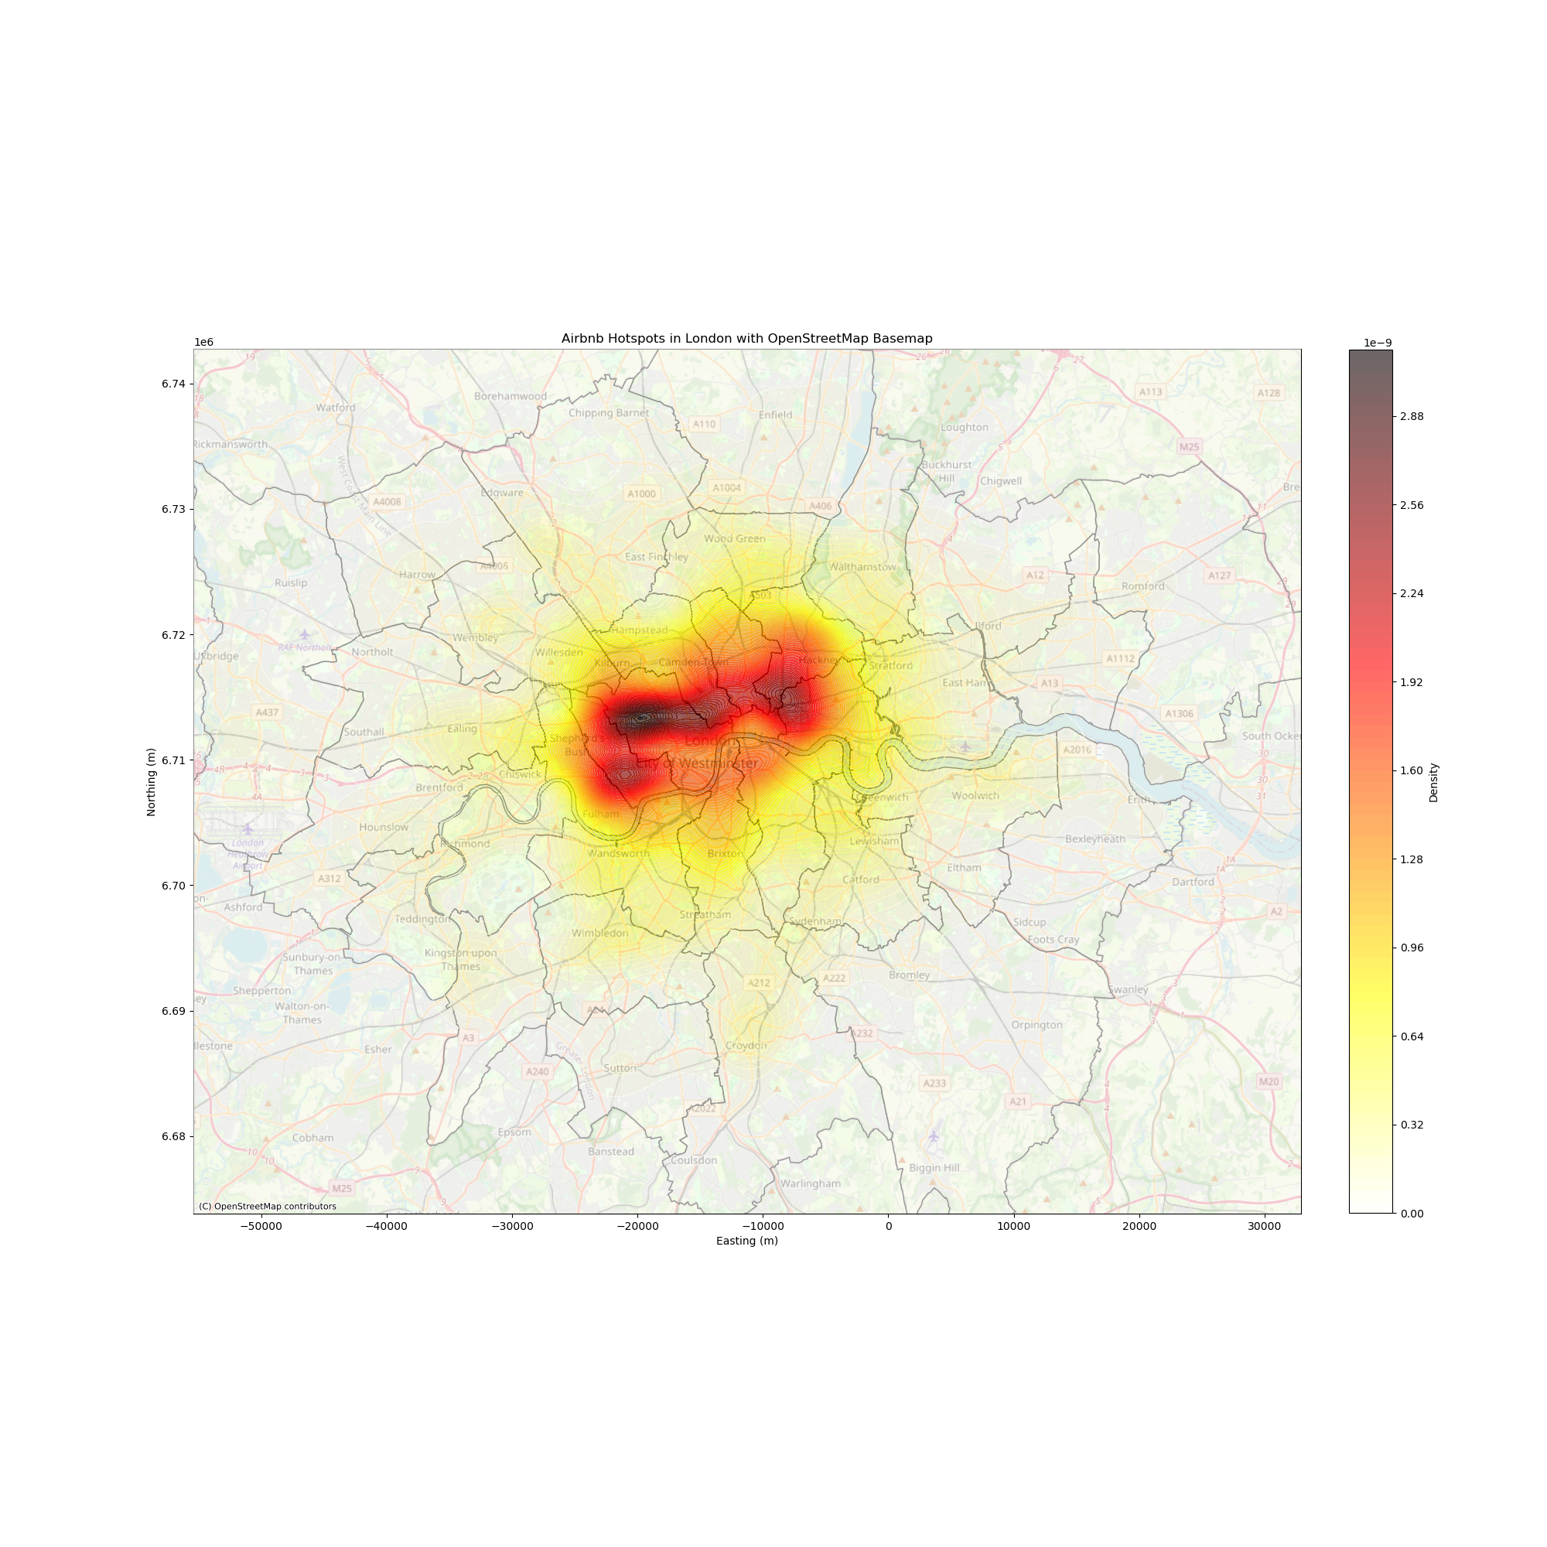

Panel Data

Due to the data spanning four continuous years of Airbnb and long-term rentals, the team chose to use panel data for analysis and presentation. Panel data merges time series and cross-sectional data into an efficient three-dimensional data structure. It facilitates the analysis of the evolution over time of three specific attributes of interest across four years. Based on this, the team performed regression calculations using a random effects model. This can be seen in the figure:

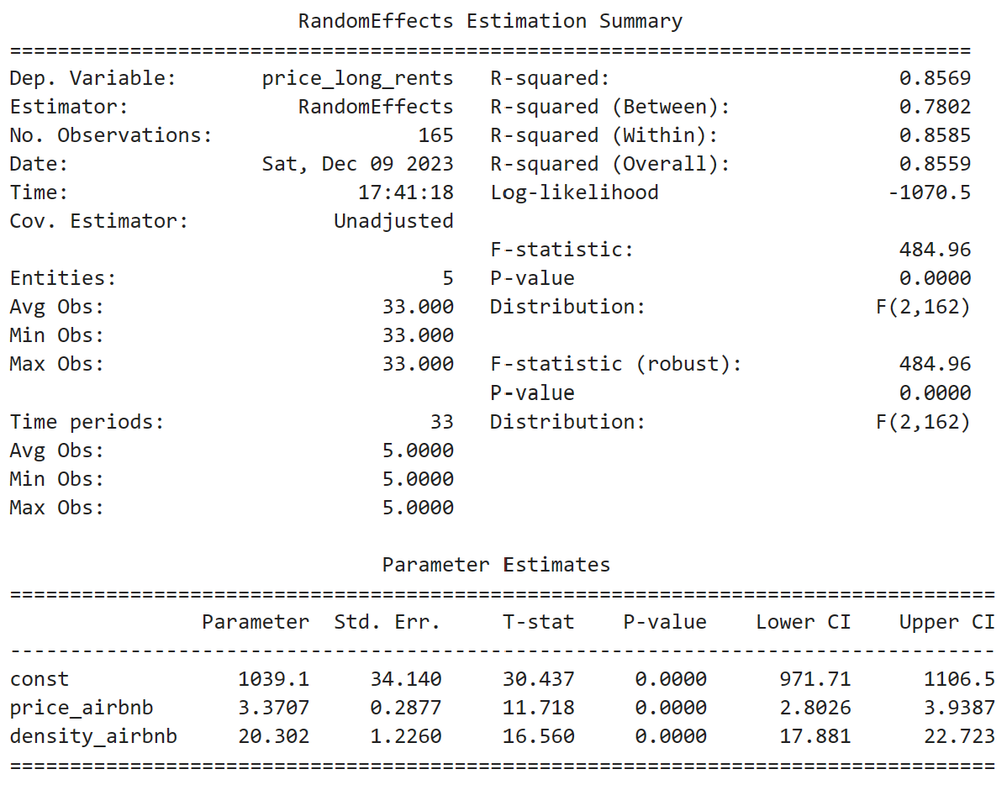

The R-squared value of 0.8569 indicates that the model explains about 85.69% of the variance in the dependent variable. The F-statistic of 484.96 is very high, meaning the model is statistically significant. The associated p-value is 0.0000, which is less than 0.05, so we can reject the null hypothesis that all model coefficients are zero. Combined with the actual long-term rental problem analyzed, the random effects model shows that Airbnb price and density have a significant positive effect on long-term rental prices. The high R-squared values indicate that the model fits the data well and that the data structure appears to be balanced with consistent observations across entities and periods.

The analysis of panel data substantiates our hypothesis. London's Airbnb market is comprised of individual and corporate landlords. The allure of Airbnb's short-term profits has led many traditional landlords to shift properties from long-term to short-term rental markets. This shift has notably increased Airbnb listing density across London. Data from 2020 to 2023 reveals that Airbnb price hikes significantly affect long-term rental prices in high-demand boroughs. For instance, in Kensington and Chelsea, a 1% Airbnb price rise corresponds to a 0.5% increase in long-term rental prices, while in high-demand Islington, the same Airbnb price rise sees a staggering 30.1% increase in long-term rents. This indicates a pronounced demand for long-term rentals in residential areas. As landlords convert long-term rentals to Airbnb listings, the imbalance of supply and demand escalates long-term rental prices.

Additionally, our findings show that for each new Airbnb listing in London boroughs, long-term rental prices rise by £2, with lower-density boroughs experiencing a greater impact. For example, a 1% rise in Airbnb density leads to a 9.5% price increase for long-term rentals in high-density Kensington and Chelsea, a 32.9% increase in moderate-density Ealing, and a 69.3% increase in low-density Sutton. From extensive research surveys, it can be surmised that areas with higher Airbnb densities are regulated by stricter policies, while areas with lower Airbnb densities are more laxly regulated. [5] Despite the same regulations, the laxity of regulation and enforcement has resulted in the price of long-term rentals being disproportionately affected by the increase in the number of Airbnb's, thus resulting in excessive rental growth.

Suggestions:

Based on the above findings， the following four recommendations are made according to the actual situation of London's Airbnb market and long-term rental market:

1. For the Airbnb platform: Limit the number of listings placed on the Airbnb platform by the same landlord. Crackdown on second-hand landlords acquiring houses in bulk and putting them on Airbnb to make the difference in price.

2. For the Airbnb platform: Raise the threshold for hosts to register on the Airbnb platform. Restricting every set of in-Airbnb hosts to being the actual house owner—crack down on speculation by second homeowners in the name of companies or individuals.

3. For government departments: improve regulation. Laxity in regulatory efforts in some regions results in long-term rentals being hit harder by Airbnb in boroughs where the density of Airbnb listings is lower.

4. For government departments: according to the specificity of each borough, stipulate the number of new Airbnb allowed within a year. For example, residential areas far away from scenic spots should be prioritized to protect the living needs of residents.

Limitations:

The dataset from 2020 to 2023 encompasses the pandemic period, which significantly disrupted the tourism sector and Airbnb market, thus skewing Airbnb's price and density from typical market trends. The data for long-term rentals were obtained from the official website, yet this data is derived from sampling methods, which means it may not accurately reflect the current state of the long-term rental market. Furthermore, when investigating the impact of Airbnb on long-term rental prices, the multitude of influencing factors, such as inflation, population mobility, and national policies, suggest that the increase in long-term rental prices observed in our study may not be entirely due to the Airbnb market.

Reference:

[1]https://ci.carmel.ca.us/sites/main/files/file-attachments/harvard_business_article_and_study.pdf

【2】

[The Effect of Home-Sharing on House Prices and Rents: Evidence from Airbnb (informs.org)](https://pubsonline.informs.org/doi/epdf/10.1287/mksc.2020.1227)

【3】

https://www.researchgate.net/profile/David-Neeser/publication/282151529_Does_Airbnb_Hurt_Hotel_Business_Evidence_from_the_Nordic_Countries/links/5605310e08aea25fce322679/Does-Airbnb-Hurt-Hotel-Business-Evidence-from-the-Nordic-Countries.pdf

【4】

<https://citeseerx.ist.psu.edu/document?repid=rep1&type=pdf&doi=c624a793606739b3af246d50f9506cfdd03e383d>

【5】

https://papers.ssrn.com/sol3/papers.cfm?abstract_id=3676909

【6】

<https://journals.sagepub.com/doi/full/10.1177/0042098020970865>

<https://uq.pressbooks.pub/airbnb-978-1-74272-321-1/chapter/the-evolution-of-airbnb-regulations/>

<https://onlinelibrary.wiley.com/doi/full/10.1111/tesg.12537>

https://arxiv.org/abs/1903.11205

Reference

*About*. (no date). Available at: http://insideairbnb.com/about/ (Accessed: 19 November 2023).

Alsudais, A. (2021). ‘Incorrect data in the widely used Inside Airbnb dataset’. *Decision Support Systems*, 141, p. 113453. doi: 10.1016/j.dss.2020.113453.